1.a

1.b

1.c

I firstly checked which features are numeric then I plot a scatterplot to show the relation ship between colleges’ application and acceptance.

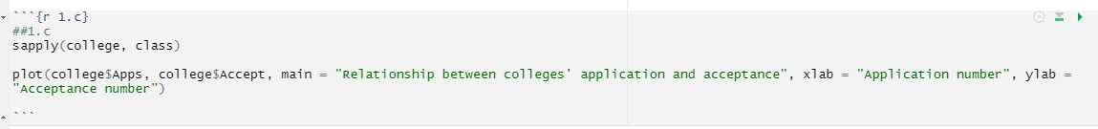

1.d

1.e

Totally there are 26 top universities.

1.f

I would like to take a deep look in graduate rates of top schools and other schools. My hypotheses was top schools had lower graduate rate since they are intuitively 'better' than other schools. However, the interesting fact is that top schools generally have higher graduate rate (around 90%) than others (around 60%). The reason probably is the students in top schools are better at studying so even it is more difficult to graduate, top schools sill have higher graduate rates.

2.a

'FFMC', 'DMC', 'DC', 'ISI', 'temp', 'RH', 'wind', 'rain', 'area' can be considered as quantitative predictors. 'month' and 'day' can be considered as qualitative predictors, but they are easily represented as quantitative predictors."

2.b

2.c

2.d

As the bar plot shows, august has the most count of forest fires.

2.e

I firstly transferred all “month” and “day” data to numeric data.

Then create correlation matrix for all relevant variables.

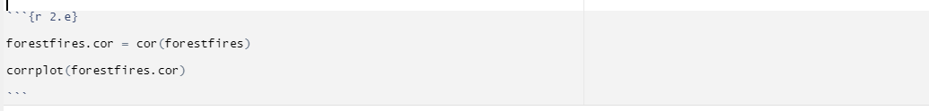

2.f

As above figure shown, temperature in degrees Celsius(temp) and relative humidity(RH ) might be useful in predicting area since the area burned by the forest fire has higher positive correlation coefficient with temp, and higher negative correlation coefficient with RH, which means the burned area goes up with the higher temperature and lower relative humidity in some cases.